1. [L1 and L2 Regularization Methods. Machine Learning | by Anuja Nagpal | Towards Data Science](https://towardsdatascience.com/l1-and-l2-regularization-methods-ce25e7fc831c)

[Scikit Learn - Elastic-Net (tutorialspoint.com)](https://www.tutorialspoint.com/scikit_learn/scikit_learn_elastic_net.htm)

2.

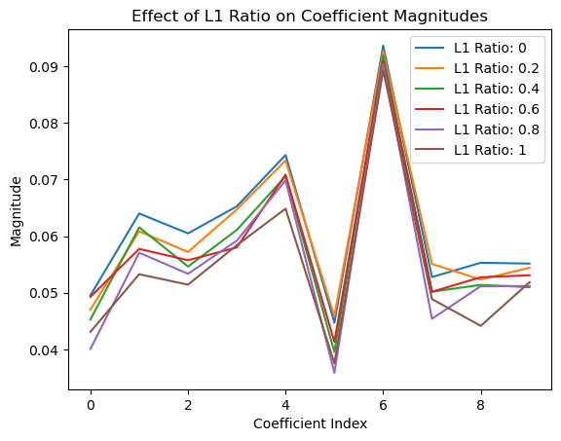

3. L1 ratio is a parameter used is SGDRegression . It is a ratio between 0 and 1 that determines the balance between using L1 penalty or L2 penalty. A higher L1 ratio means that the model may ignore some features, which means it is using L1 penalty and a lower L1 means that the model will use all features in different weights, with smaller impacts, L1 penalty.

The difference between them is that L1 selects some features to be used in the model, whereas L2 uses all the features in small values.

This parameter prevents overfitting.

4. When to use this parameter?

It helps prevent overfitting, good to use when the model is too complex. Good to use when dealing with high-dimensional datasets or situations where there may be correlation among the features.

5. No questions!

6.

from sklearn.linear_model import SGDRegressor

model = SGDRegressor(loss='squared_loss', penalty='elasticnet', alpha=0.01, l1_ratio=0.7)

model.fit(X_train, y_train)

predictions = model.predict(X_test)

7. Used for both SGDRegression and SGD Classifier